Project:

Macros:

#define LD 0

#define ST 1

#define ADD 2

#define SUB 3

#define MULT 4

#define DIV 5

#define HALT 6

#define WAIT_FOR_OPERANDS = 0

#define EXECUTING = 1

#define WAIT_FOR_WRITE_RESULT = 2

Structs:

1. inst_queue (fifo – because issue is in order)
   * int num_inst_in_queue
   * inst* inst_list -> linked list / instruction[16]
2. inst:
   * int pc
   * int imm -> from parsing
   * int src_0 -> from parsing
   * int src_1 -> from parsing
   * int dst -> from parsing
   * int opcode -> from parsing
   * int cycle_issue -> at parsing set to -1
   * int cycle_read_operands -> at parsing set to -1
   * int cycle_execute_end -> at parsing set to -1
   * int cycle_write_result -> at parsing set to -1
3. func_unit:
   * char* unit -> SUB0 SUB1 SUB2

name given in parsing by the create_func_unit_status_table

* + int type -> SUB (macro). Given an parsing.
  + int delay -> Given at parsing
  + int state (WAIT_FOR_OPERANDS, EXECUTING, WAIT_FOR_WRITE_RESULT)
  + int remaining_time -> reset_func_unit changes back to delay
  + int busy
  + dst_reg (Fi)
  + src_reg_1 (Fj)
  + src_reg_2 (Fk)
  + …

Globals:

int clk_cycle = 0 - clock cycle

int pc = 0 - next instruction to fetch

int mem[4096] - memory image

float regs[16]   - processor float registers.

// Scoreboard

func_unit* func_unit_status_table -> point to a dynamically allocated array

char* reg_result_status_table [16] -> point to NULL of name of unit

// Status

char* trace_unit_name - unit to be traced (according to cfg.txt)

inst next_inst_to_be_issued

inst finished_inst[4096] - array of finished instructions

in order to prevent “glitches”:

for each data base the main.c will hold an “updated” version

and in end of loop :

struct_1 = updated_struct_1

struct_2 = updated_struct_2

Functions:

// Read memory file

1. read_memory_into_mem_array

// parsing

1. create_func_unit_status_table
2. set_trace_unit_name
3. create_inst -> create inst struct from line in file

// scoreboard flow (based on the “green” table from the lecture)

1. issue_possible

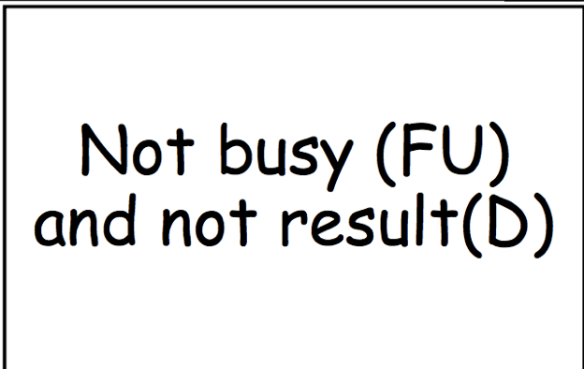

1. issue

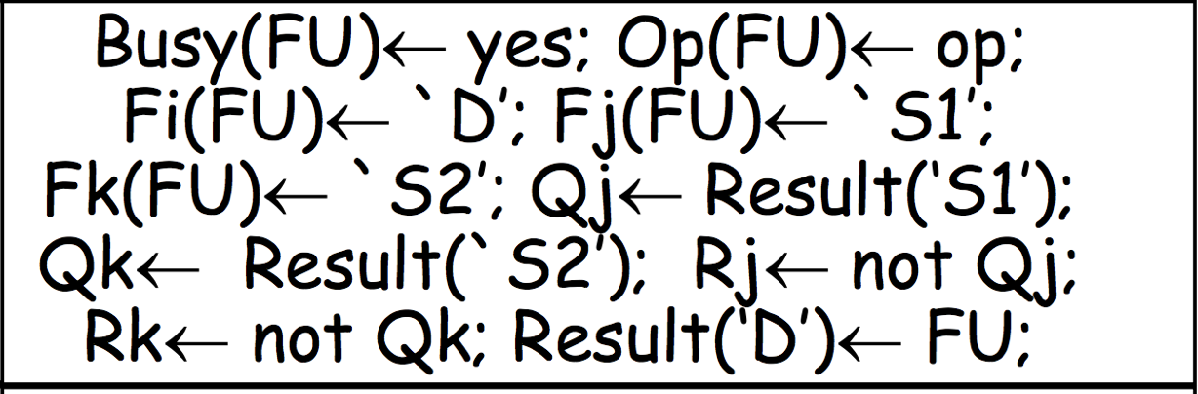

+ inst.issue_cycle == clk_cycle

1. operands_ready

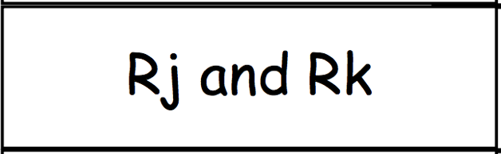

1. read_operands

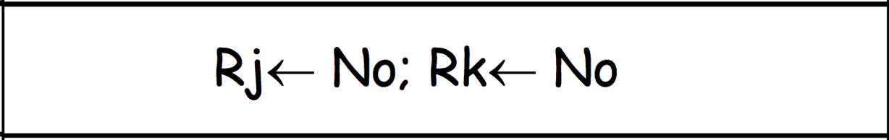

+ inst.read_operands_cycle == clk_cycle

1. func_unit_done
2. write_result_possible

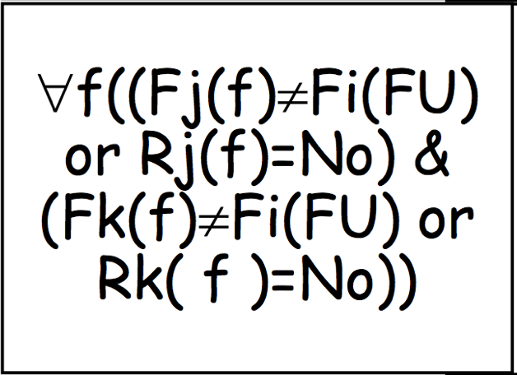

1. write_result

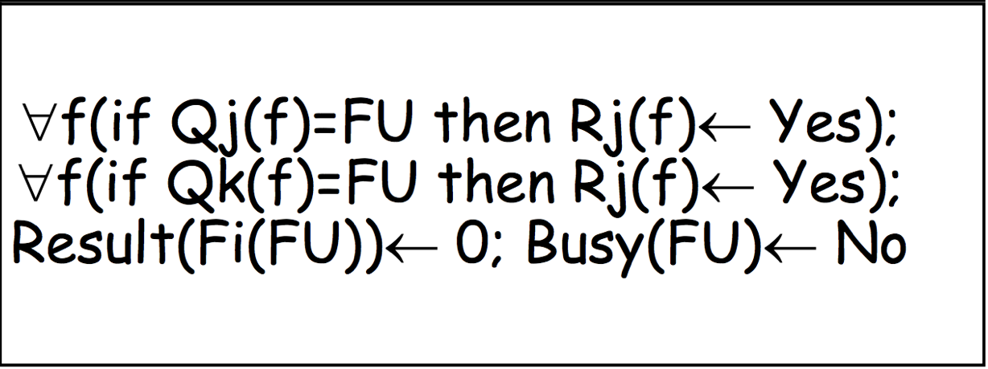

+ inst.write_result_cycle == clk_cycle

1. reset_func_unit -> return the unit to reset state. Resets all fields except unit, type and delay

// write final memory

1. write_mem_image_to_file
2. write_reg_image_to_file

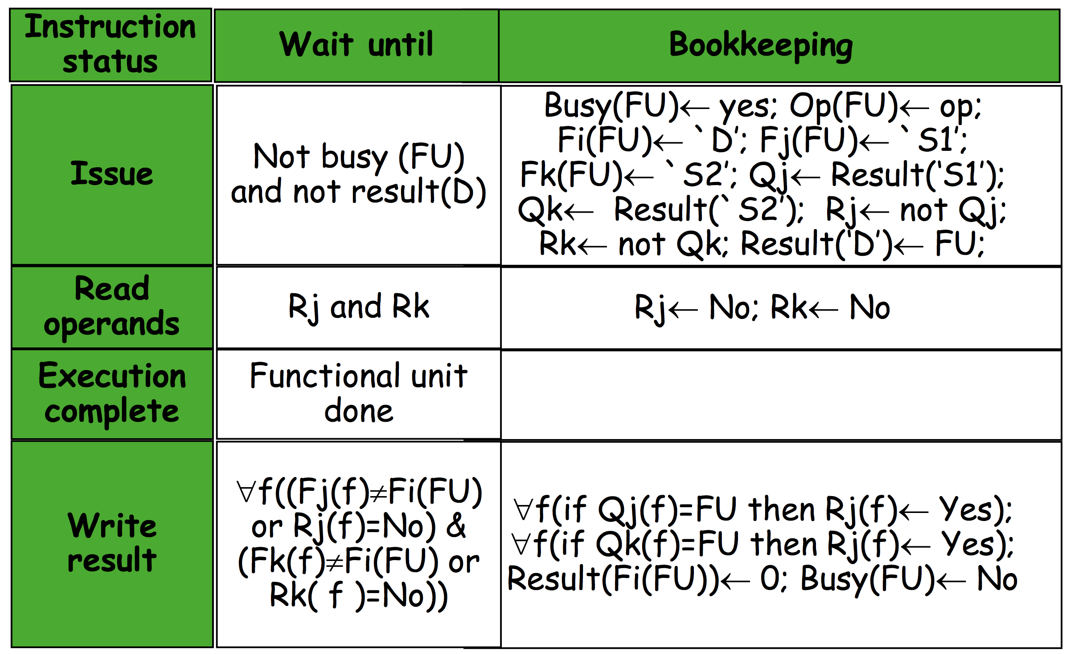

**flow – pseudo code :**

// Read Memory

open memin.txt

read_memory_into_mem_array

close memin.txt

// Read Configuration

open cfg.txt

create_func_unit_status_table

set_trace_unit_name

close cfg.txt

** open traceunit.txt -> file written on the fly

while { (the set operations executed in each clock cycle)

// FETCH (to instruction_queue)

if (inst_queue.num_inst_in_queue < 16) // 16 defined in project

inst_queue.push(fetch_inst(pc,updated_inst_queue))

pc += 1

// ISSUE (only one instruction can be waiting to be issued)

inst = create_inst(inst_queue.get_head)

if(inst.opcode == HALT)

break -> exit while loop

if(issue_possible)

inst_queue.pop

issue

// READ_OPERANDS + EXEC + WRITE RESULT

for unit in func_unit_status_table:

if (unit.unit == trace_unit_name)

print to traceunit.txt the necessary data on the unit

if(unit.state == WAIT_FOR_OPERANDS)

if(operands_ready)

read_operands(inst)

unit.state = EXECUTING

if(inst.state == EXECUTING)

if(func_unit_done)

unit.state = WAIT_FOR_WRITE_RESULT

else

unit.remaning_time -= 1

if(unit.state == WAIT_FOR_WRITE_BACK)

if(write_result_possible)

write_result

reset_func_unit

finished_inst[inst.pc] = inst -> pass inst to finished list

clk_cycle += 1

}

** close traceunit.txt

// Printing Stage

open memout.txt

write_mem_image_to_file

close memout.txt

open regout.txt

write_reg_image_to_file

close regout.txt

open traceinst.txt

print traceinst.txt -> according to finished_inst array

close traceinst.txt

// Termination

… free all dynamically allocated memory …